Phys 135A College Physics I

Activity 6: Newton’s Second Law

How does a cart change its motion when you push and pull on it? You might think that the harder you push on a cart, the faster it goes. Is the cart’s velocity related to the force you apply? Or does the force just change the velocity? Also, what does the mass of the cart have to do with how the motion changes? We know that it takes a much harder push to get a heavy cart moving than a lighter one.
A Force Sensor and an Accelerometer will let you measure the force on a cart simultaneously with the cart’s acceleration. The total mass of the cart is easy to vary by adding masses. Using these tools, you can determine how the net force on the cart, its mass, and its acceleration are related. This relationship is Newton’s second law of motion.
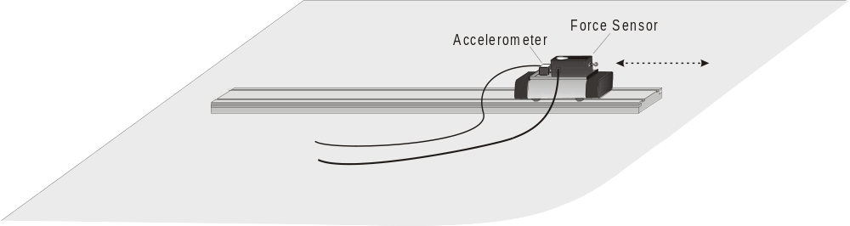
Figure 1
Objectives
- Collect force and acceleration data for a cart as it is moved back and forth.
- Compare force vs. time and acceleration vs. time graphs.
- Analyze a graph of force vs. acceleration.
- Determine the relationship between force, mass, and acceleration.
Materials
computer | Vernier Force Sensor
Vernier computer interface | low-friction dynamics cart
Logger Pro | 0.500 kg mass
Vernier Low-g Accelerometer

Preliminary questions
1. When you push on an object, how does the magnitude of the force affect its motion? If you push harder, is the change in motion smaller or larger? Do you think this is a direct or inverse relationship?
2. Assume that you have a bowling ball and a baseball, each suspended from a different rope. If you hit each of these balls with a full swing of a baseball bat, which ball will change its motion by the greater amount?
3. In the absence of friction and other forces, if you exert a force, F, on a mass, m, the mass will accelerate. If you exert the same force on a mass of 2m, would you expect the resulting acceleration to be twice as large or half as large? Is this a direct or inverse relationship?
Procedure
- Connect a Dual-Range Force Sensor to Channel 1 on the Vernier computer interface. Connect the Low-g Accelerometer to Channel 2 on the interface.
2. Open the file “09 Newtons Second Law” from the Physics with Computers folder.
3. Attach the Force Sensor to a dynamics cart so you can apply a horizontal force to the hook, directed along the sensitive axis of your particular Force Sensor. Next, attach the Accelerometer so the arrow is horizontal and parallel to the direction that the cart will roll. Orient the arrow so that if you pull on the Force Sensor the cart will move in the direction of the arrow. Find the mass of the cart with the Force Sensor and Accelerometer attached. Record the mass in the data table.
4. Place the cart on a level surface. Make sure the cart is not moving and click . Check to make sure both sensors are highlighted and click .
Trial I
5. You are now ready to collect force and acceleration data. Grasp the Force Sensor hook. Click  and take several seconds to move the cart back and forth on the table. Vary the motion so that both small and large forces are applied. Make sure that your hand is only touching the hook on the Force Sensor and not the Force Sensor or cart body.
6. Note the shape of the force vs. time and acceleration vs. time graphs. Click the Examine button, 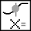, and move the mouse across the force vs. time graph. When the force is maximum, is the acceleration maximum or minimum? To turn off Examine mode, click on the Examine button, .
7. The graph of force vs. acceleration should appear to be a straight line. To fit a straight line to the data, click on the graph, then click the Linear Fit button, 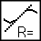. Record the equation for the regression line in the data table.
8. Using the graphs, estimate the acceleration of the cart when a force of 1.0 N has acted upon it. Select Interpolate from the Analyze menu. Move the mouse across the graph and determine the acceleration (x) when the force (y) is nearly 1.0 N. Record the force and acceleration in the data table.
9. Repeat Step 8 using a force of –1.0 N.
Trial 2
10. Attach the 0.500 kg mass to the cart. Record the mass of the cart, sensors, and additional mass in the data table.
11. Repeat Steps 5 – 9.
Data Table
Trial I
Mass of cart with sensors (kg)
Regression line for force vs. acceleration data
 | Force pulling cart (N) | Acceleration (m/s2)
Force closest to 1.0 N
Force closest to –1.0 N
Trial 2
Mass of cart with sensors and additional mass (kg)
Regression line for force vs. acceleration data
 | Force pulling cart (N) | Acceleration (m/s2)
Force closest to 1.0 N
Force closest to –1.0 N

Analysis
- Compare the graphs of force vs. time and acceleration vs. time for a particular trial. How are they different? How are they the same?
- Are the net force on an object and the acceleration of the object directly proportional? Explain.
- What are the units of the slope of the force vs. acceleration graph? Simplify the units of the slope to fundamental units (m, kg, s).
- For each trial compare the slope of the regression line to the mass being accelerated. What does the slope represent?
- Write a general equation that relates all three variables: force, mass, and acceleration.
Extensions
- Use this apparatus as a way to measure mass. Place an unknown mass on the cart. Measure the acceleration for a known force and determine the mass of the unknown. Compare your answer with the actual mass of the cart, as measured using a balance.

